Name Madison Wilson__________

|  |
| --- |
| **Activity 1.2.5 Analog and Digital Signals** |

Introduction

Even though this is a course in digital electronics, it is important to understand that the world around us is analog. Virtually everything that can be designed with digital electronics is used to either control or monitor something in the world around us, and this world is analog. Thus, to be an effective designer of digital electronics, it is important for you to understand the characteristics of both analog and digital signals.

In this activity you will examine several analog and digital signals to determine their amplitude, period, and frequency. Additionally, you will gain experience using the oscilloscope within the Circuit Design Software (CDS).

Equipment

* Paper & pencil
* Circuit Design Software (CDS)
* Calculator

Procedure

1. For each of the two analog signals shown below, determine their amplitude (peak), amplitude (peak-peak), period (T), and frequency (F). Be sure to put your answer in proper engineering notation and use the correct units.

|  |  |
| --- | --- |
| Amp (peak):  5V*1.5= 7.5V |  |
| Amp (peak-peak): |
| Period:  T=3.1*200ns=  620ns |
| Frequency:  =1/T=1/620ns= .0161= 16.1microHertz |

|  |  |
| --- | --- |
| Amp (peak):  2*1= 2V |  |
| Amp (peak-peak): |
| Period:  =2*500us=1000us  1ms |
| Frequency:  =1/T=1/1=1 |

Note: Why isn’t the above signal considered a digital signal?

The first picture is an analog signal because of the wavy line, anywhere on the y coordinate you get a number, the second one is a digital signal because it is boxy, in other words its always either on or off.

1. For each of the two digital signals shown below, determine the amplitude, period (T), frequency (F), time high (tH), time low (tL), and duty cycle (DC). Be sure to put your answer in proper engineering notation and use the correct units.

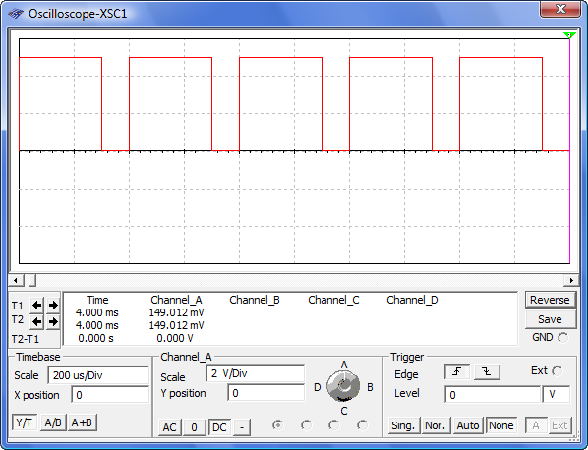

|  |  |
| --- | --- |
| Amplitude:2.5*2V= 5V |  |
| Period:2*200us=400us |
| Frequency:1/T=1/400= .0025= 2.5mHz |
| Time High:1.5*2V= 3 |
| Time Low:1.5*.5= .75 |
| Duty Cycle:= th/T*100%= 3/400*100&= .75% |

|  |  |
| --- | --- |
| Amplitude:2.5/2=5 |  |
| Period:3.5*500us= 1750 |
| Frequency:1/1750=5.714Hz |
| Time High:.33*2=.66 |
| Time Low:3*2v=6 |
| Duty Cycle:.66/1750*100%=.0371% |

1. Using the Circuit Design Software (CDS), enter the test circuit shown below. This circuit consists of a CLOCK_VOLTAGE, a DC_POWER (battery) and two 5v LAMPS. This circuit doesn’t really do much of anything useful other than make the two lamps flash, but we will be using it to gain experience using the oscilloscope to measure signals.

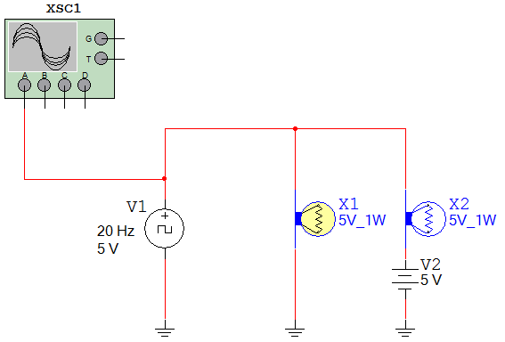

1. Open the CLOCK_VOLTAGE component by double clicking on it and set the frequency, duty cycle, and voltage to 20 Hz, 10%, and 5 volts.
2. Likewise, open the DC_POWER and set the voltage to 5 volts.
3. Finally, connect the OSCILLOSCOPE to the positive side of the CLOCK_VOLTAGE component.
4. Start the simulation. Are the lamps flashing? Does the flashing rate make sense for the frequency and duty cycle of the CLOCK_VOLTAGE? If not, review your setup and make any necessary corrections. Yes, they’re flashing, it makes sense based up on the duty cycle of the CLOCK VOLTAGE
5. Now that the circuit is working, use the oscilloscope to measure the signal being generated by the CLOCK_VOLTAGE. Use the markers to measure the period, time high, and time low. Use this data to calculate the frequency and duty cycle of the signal. 

Period-50 ms

Time high- 5ms

Time Low- 45ms

F=1/T(period) measured in hurtz

Duty Cycle= th/T x 100%

1. Do the measured (and calculated) values match those set up in the CLOCK_VOLTAGE device? If not, review your measurements and make any necessary corrections.

**Conclusion**

1. List the characteristic that makes a digital signal different from an analog signal.

Shape of the wave and the possible values on the y-axis, analog can have a range, and digital is either 0 or the maximum point or amplitude.

1. In the diagram shown below, label the parts of the analog signal.

Period

Amplitude

1. In the diagram shown below, label the parts of the digital signal.

Time High

Period

Time Low

Amplitude

1. What are the two standard voltage levels that are acceptable for a digital signal?